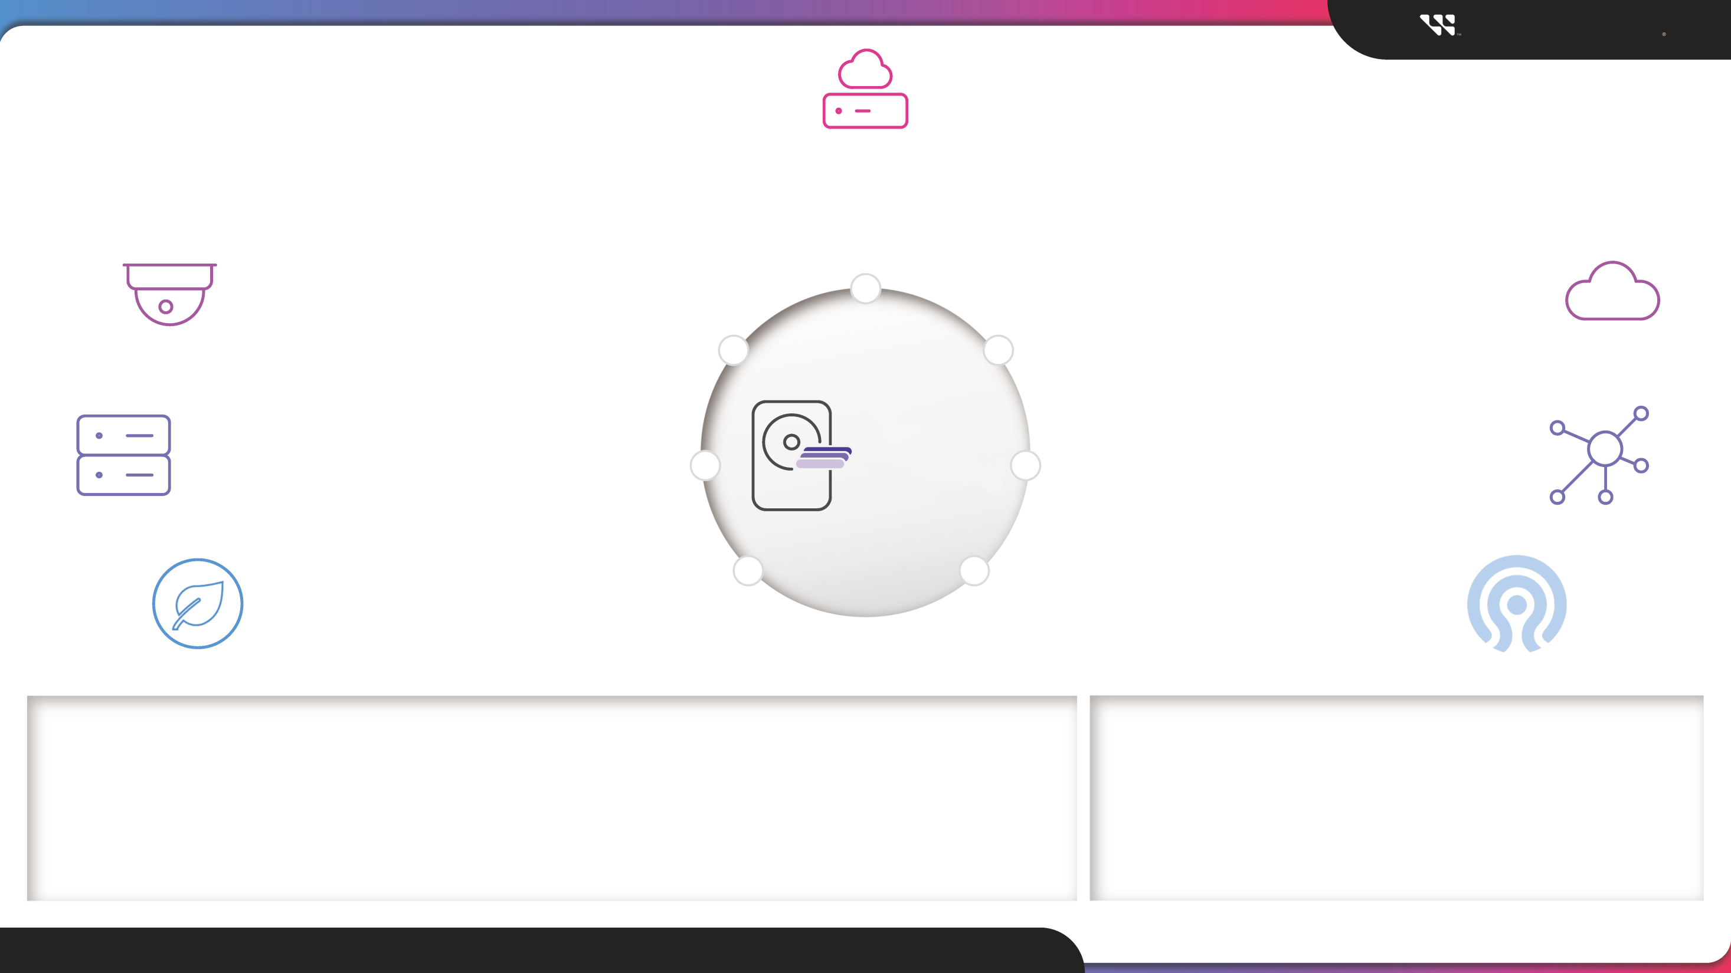

*Where to*

*in Linux & btrfs environments*

**Sell SMR**

**Western Digital**

# Smart Video / Surveillance

Customers have been actively testing SMR

# Cold / Archival Storage

“Write once, read many” (WORM) applications

# Storage-based Cryptocurrency

Chia successfully tested SMR

# Ceph-based Object Storage

Native support will be available in 2024

# Content Delivery Networks

Low-write, heavy-read applications

# Select Cloud Storage

With versioning, edits are not overwritten in-place

# Cloud Backup

In 2019, Dropbox became the world’s 1st major tech company to successfully adopt SMR

© 2023 WESTERN DIGITAL CORPORATION OR ITS AFFILIATES ALL RIGHTS RESERVED | WESTERN DIGITAL CONFIDENTIAL

**SMR Quick Facts**

• **Shingled Magnetic Recording (SMR)** fits more data on a disk by writing data in overlapping tracks like shingles on a roof.

• **Data must be written sequentially** (in order) but can be read randomly like a traditional CMR HDD.

• Customers with **low-write applications** can use SMR for higher capacity and a more efficient footprint.

• SMR will be shipping for the long-term future to further increase **HAMR HDD** capacities.

**SMR Resources**

• **SMR Sell-in Deck**

• **SMR Adoption PPT (Internal Only)**

• **SMR-Friendly vs SMR-Aware | Infographic**

• **All SMR Resources**